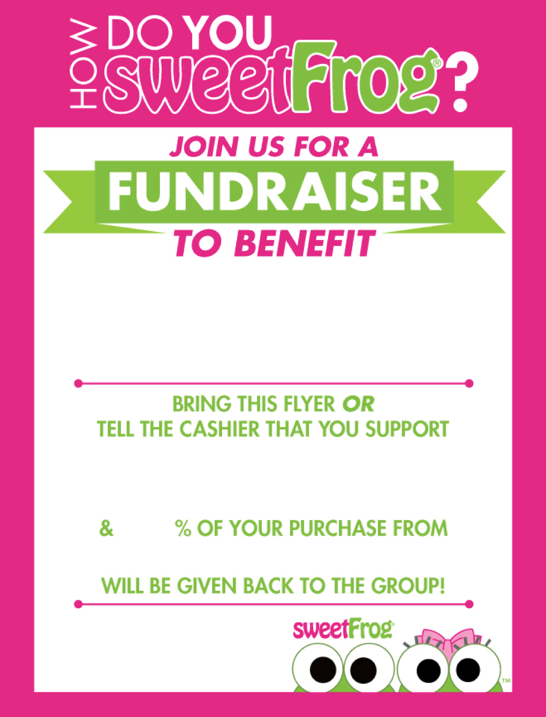

**Event Time: 3:00PM to 9:00 PM**

25% of the sales generated from this event

will be given back to the organization!

(**We cannot accommodate usage of other discounts in conjunction with this program)**

To find out more, email: [marketing@mysweetfrog.net](mailto:marketing@mysweetfrog.net)

**Floris Elementary School**

**Event date: Thursday, August 24th**

**!**

**BRING IN THIS FLYER, OR TELL YOUR CASHIER**

13601 Lee Jackson

Memorial Highway

Fairfax, VA